24.37: Let the applied voltage be V. Let each capacitor have capacitance 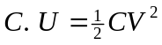 for a single capacitor with voltage V.
a) series
Voltage across each capacitor is 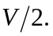 The total energy stored is
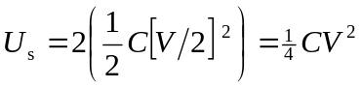
parallel
Voltage across each capacitor is V. The total energy stored is
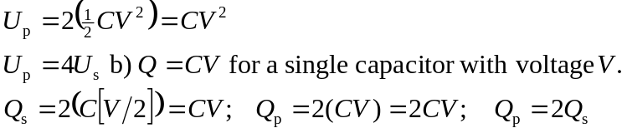
c)
